Brainstorming & Ideation
Ideation Canvas
Date | 12 July 2026
Team ID | SWTID-2026-4644
Project Name | Smart Lender
Phase | 1. Brainstorming & Ideation

Purpose
The Ideation Canvas widens the lens from a single persona (the Empathy Map) to the full context surrounding the problem: the people involved, their activities, the situation they operate in, and the props (locations, products, and objects) they interact with. Together these four lenses converge on possible solutions at the center of the canvas.

Ideation Canvas
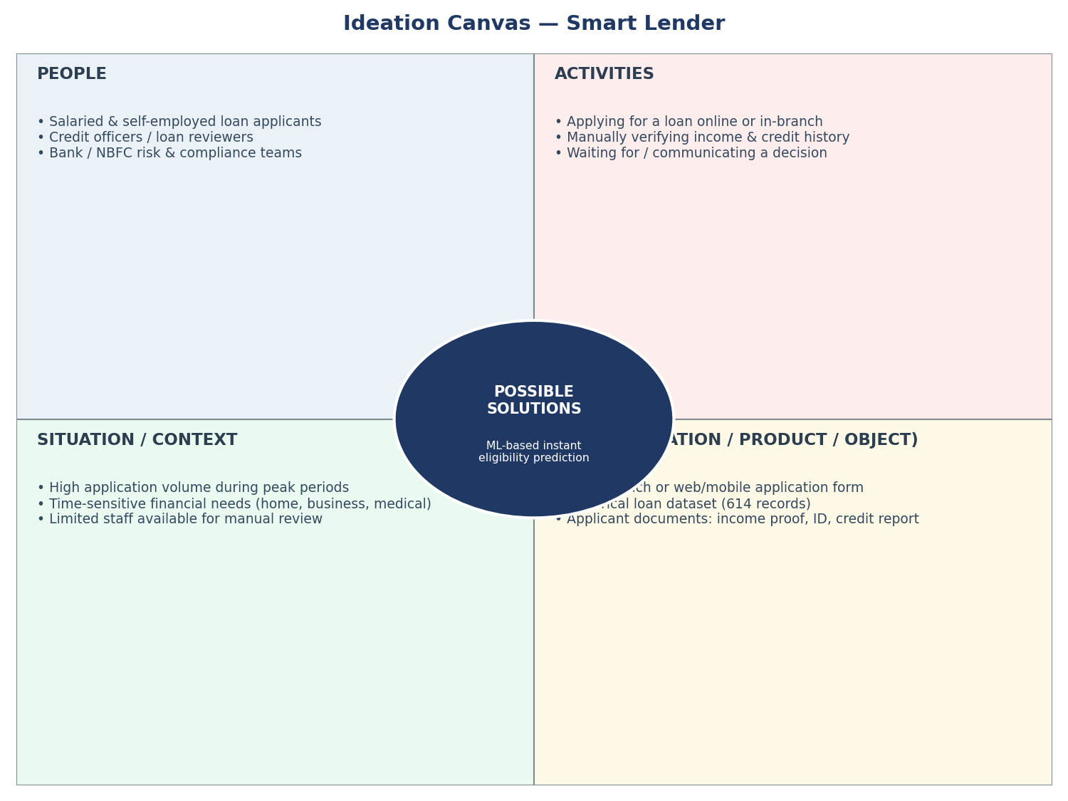
Figure 1: Ideation Canvas — Smart Lender.

Quadrant Detail

People
- Salaried and self-employed loan applicants — the primary users experiencing the delay.
- Credit officers / loan reviewers — the primary users experiencing the inconsistency and volume pressure.
- Bank / NBFC risk and compliance teams — indirect stakeholders concerned with default risk and regulatory soundness.

Activities
- Applicants: filling in personal, financial, and property details; waiting for and following up on a decision.
- Officers: manually cross-checking income, credit history, and documentation for each file; approving or rejecting based on judgment.

Situation / Context
- Application volume spikes during specific periods (e.g., festive/home-buying seasons), straining manual review capacity.
- Applicants often have a time-sensitive need (home purchase, business capital, medical expense) that makes delay costly.

Props (Location / Product / Object)
- The application channel itself — branch visit or web form — is the primary touchpoint that any solution must work within.
- The historical loan dataset (614 records, 13 columns) is the raw material for any data-driven solution.

Possible Solutions (Convergence)
Converging all four lenses, the team converged on: an ML-based instant eligibility prediction, delivered through the applicant's existing web-form channel, trained on the bank's own historical loan data, and designed to support — not replace — the credit officer's final judgment. This is the same MVP scope carried forward into Brainstorming_Template.docx and validated in the Requirement Analysis phase.

